**What Meaneth Then?**

Bob Howton / East Point Bulletin

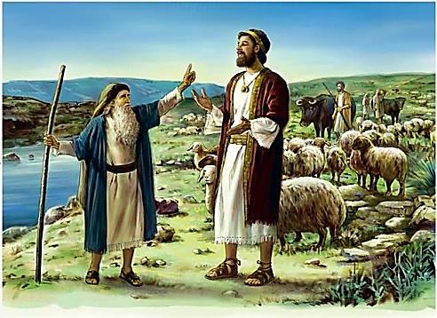

The book of 1 Samuel is a heartwarming disclosure of God’s loving providence to those who love and obey Him. At the same time, it paints a vivid and fearful picture of the wrath of God upon those who turn a deaf ear to His Word. Look at the clear definition of God’s instructions to utterly destroy the people of Amalek. Then witness the foolish imposition of King Saul’s flawed judgment, which he used instead.

***“Now go and smite Amalek, and utterly destroy all that they have, and spare them not; but slay both man and woman, infant and suckling, ox and sheep, camel and ass.”*** (**1 Samuel 15:3**) With these clear instructions before us, take a look at what Saul did instead! ***“But Saul and the people spared Agag, and the best of the sheep, and of the oxen, and of the fatlings, and the lambs, and all that was good, and would not utterly destroy them; but every thing that was vile and refuse, that they destroyed utterly.”*** (**1 Samuel 15:9**) Verse eleven shows God repenting that He had made Saul king.

The results of this self-willed disobedience is spelled out, ***“And Samuel came to Saul: and Saul said unto him, ‘Blessed be thou of the Lord: I have performed the commandment of the Lord.’ And Samuel said, ‘WHAT MEANETH THEN, this bleating of sheep in mine ears, and the lowing of oxen which I hear.’”*** (**1 Samuel 15:13-14**) Doesn’t it seem incredible that one so blessed, should turn a deaf ear to the instructions of his benefactor?

So, you’re a child of the Most High God! You have heard His Word (**Romans 10:17**), you have believed that Word (**Hebrews 11:6**), you have repented of past sins (**Acts 17:30**), you have confessed Christ as God’s Son (**Philippians 2:11**) and you have been baptized for the remission of your sins (**Mark 16:16**) **What meaneth then**, your failure to walk in newness of life? (**Romans 6:4**)

So, your name is a “church roll” where you are counted as a child of God! **What meaneth then**, your failure to be stedfast, unmovable, always abounding in the work of the Lord? (**1 Corinthians 15:58**)

So, God has blessed you with reasonable health and prosperity! **What meaneth then**, your failure to give sacrificially each Lord’s Day as commanded? (**1 Corinthians 16:1-2**)

So, you appreciate others having kind words and friendliness to you! **What meaneth then**, your failure to be friendly to others? (**Proverbs 18:24**) And why, do you not treat others as kindly as you’d like to be treated by them? (**Ephesians 4:32**)

So, God has blessed you with a sound, reasoning mind that is able to discern good from evil! **What meaneth then**, you’re being obsessed with earthly, worldly thoughts at the expense of thinking on things which God has specified? (**Philippians 4:8**)

While we look with disbelief at Saul’s rebellion, let us look into the mirror of our own lives and realize, ***“O that thou hadst hearkened to My commandments! Then had thy peace been as a river, and thy righteousness as the waves of the sea.”*** (**Isaiah 48:18**) ***“So teach us to number our days.”***  (**Psalm 90:12**)