The Anvil – God’s Word
(author unknown)

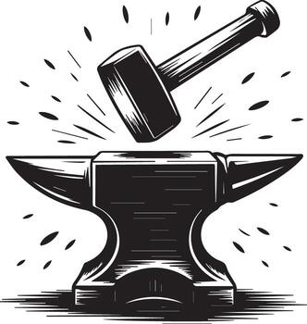

Last eve I passed beside a blacksmith’s door,
And heard the anvil ring the vesper chime;
Then, looking in, I saw upon the floor
Old hammers, worn with the beating years of time.

“How many anvils have you had,” said I,
“To wear and batter all these hammers so?”
“Just one,” said he, and then, with twinkling eye,
“The anvil wears the hammers out, you know.”

And so, thought I, the anvil of God’s Word,
For ages skeptic blows have beat upon;
Yet, though the noise of falling blows was heard,
The anvil is unharmed – the hammers gone.

