**One Small Step For Man…**

Ken Sils

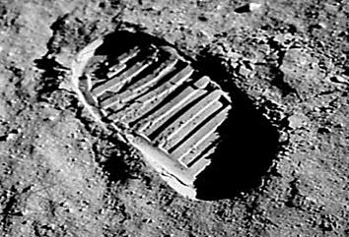

Yesterday was the 50th anniversary of Neil Armstrong’s famous first words ever uttered by man standing on the moon. I know, there’s some question as to the accuracy of this quote but, what we heard on our “black and white” TV was, ***“One small step for man, one giant leap for mankind.”*** There is the iconic photo – possibly the first footstep ever!

I remember watching this as a boy and thinking , “WOW, I want to do that! I want to go up there in outer space and walk on the moon someday!” The facts bear out that a lot of boys and girls thought the same thing! Society was “moon” and “science” hungry as QUISP cereal became the breakfast of future astronauts!

A lot of good came out of the 1960’s space exploration! In a time of raucous political upheaval, our country found unity in pursuing a dream which seemed to be unreachable with the technology available among society. We have much today due to those who pursued JFK’s dream, having cell-phones with far more technological advance than their entire NASA system. We’ve all been blessed from that ***“one small step for man!”***

I saw a quote from a brother this weekend that pointed out that one day; he was going beyond the moon on his way to heaven. That is also a great point. I mentioned back to him, ***“What shall it profit if a man gains the whole “moon” and loses his own soul?”*** Friend, we’ll all make that journey… to infinity and beyond! Are we ready, today?