**Lessons From The Melodeon At Midway – Part #1**

Andy Sochor – conclusion to part #1

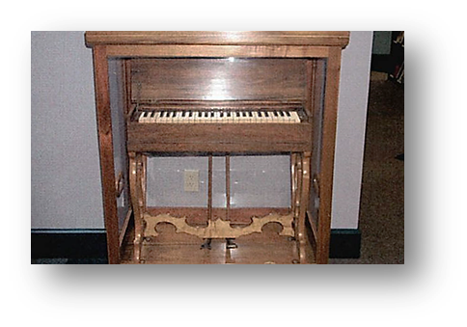

The New Testament teaches that we are to sing. Paul wrote, ***“Let the word of Christ richly dwell within you, with all wisdom teaching and admonishing one another with psalms and hymns and spiritual songs, singing with thankfulness in your hearts to God”*** (**Colossians 3:16; cf. Ephesians 5:19**). The purpose behind singing is twofold: to offer praise to God and to teach and admonish our brethren. Nowhere in the New Testament does it say anything about singing needing to be pleasing to our ears. The ability of one to carry a tune is not necessary to obey Paul’s instruction. Might we prefer good singing? Of course, but we are not to depart from the pattern based upon our preference. As long as we are singing as Paul instructed, regardless of our vocal ability, we are pleasing God.

We must guard against the tendency to let our preferences and what we perceive to be problems trump the divine pattern. We might prefer to baptize more people, but we must not change the gospel message in order to convert them (**Galatians 1:8-9**). We might prefer to spend more time with our brethren, but we must not turn the assembly into a time for common meals (**1 Corinthians 11:22, 34**). There are many things we might prefer, but we must first be concerned with what is authorized.

**Gradual Slide Into Apostasy**

The answer to the congregation’s poor singing was not immediately to bring an instrument into the assembly. Instead, the first step toward apostasy was an innocent one. Some of the brethren would meet together in their homes to practice singing. Then they decided to use a melodeon that was in the home in which there were meeting to get the right pitch (like we might use a pitch pipe today). Then the small steps continued. They went from using the instrument to get the starting pitch to having one of the women accompany the singing of psalms, hymns and spiritual songs by playing the instrument. They noticed that the accompaniment improved their singing, so they decided to bring it into their assembly. (Part #2 – next week, Lord willing)