**Lessons From The Melodeon At Midway – Part #1**

Andy Sochor / Plain Bible Teaching

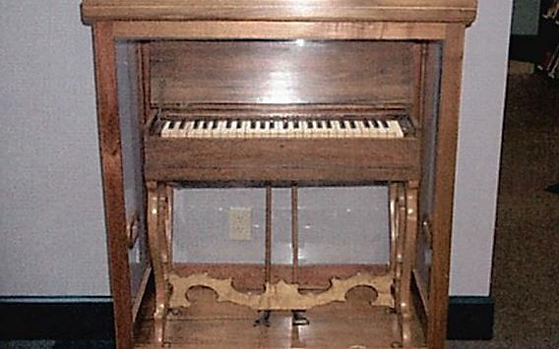

One of the most significant events of the Restoration Movement was the introduction of a melodeon in the assembly of the church in Midway, Kentucky. According to L.L. Pinkerton, the preacher at Midway, this was the first time an instrument had been successfully introduced among those of the Restoration Movement. He made this claim in 1860.

The reason why this was significant was because of the plea voiced by the preachers of the Restoration – speak where the Bible speaks and be silent where it is silent. Every religious practice would have to pass the test of Scripture. If one could not demonstrate that a practice was according to the New Testament pattern (**2 Timothy 1:13**), that practice was to be rejected because everything must be done by the authority of Christ (**Colossians 3:17**). Therefore, instrumental music in worship was widely rejected in the Restoration Movement. It did not fit the pattern revealed in the New Testament which, therefore, made it unauthorized.

So how did the melodeon find its way into the worship of the church in Midway? It certainly did not happen overnight. If we can learn the lessons from this event, then we will hopefully be prepared to guard ourselves against potential apostasies today.

**Perceived Problems**

The introduction of the melodeon at Midway was the eventual response to a perceived problem. According to Pinkerton, the singing of the congregation was so bad it would “scare even the rats from worship.” This is a problem – at least by human reasoning it is. But Biblically speaking, is bad singing really a problem? (continued on the back)