**Intentions -- Won't Get It!**

Dee Bowman – Auburn Beacon

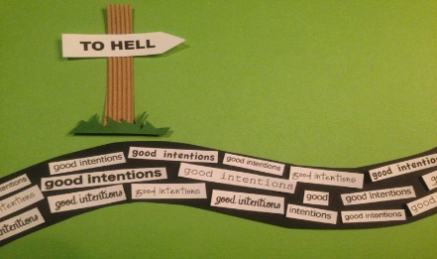

Some of the proverbial expressions not found in the Bible are nonetheless true. Truth will always plumb with all other truth; it cannot contradict itself. Take the expression, *“the road to hell is paved with good intentions.”* That’s not found in the Scriptures, but it’s nonetheless true. Nobody really wants to go to hell; and everybody I know of intends to do something to preclude making that trip. But when? Ah, that’s the question. Intention without follow-through is profitless. No matter how firm they are, they are still just intentions and serve no useful purpose until they are actuated.

Intentions won’t get it. ***“I intend to be more diligent.”*** When? Right away? Diligence is necessary to progress in spiritual living. You can’t sit around and become spiritual. Furthermore, diligence doesn’t come by some process of osmosis – just because you are in close proximity to a Bible or to those who believe it and are involved in it. Diligence is personal – a personal, willful action. You decide to be diligent. In **2 Timothy 2:15**, Paul says, ***“Give diligence to present yourself approved to God.”*** The English word translated diligence is from a Latin word which means to give earnest persistence to a matter. The Greek word for diligence means both an earnest zeal and a burning haste to get a matter done. You can’t sit around and be diligent. Peter tells us something about diligence when he uses that same term when to conclude what we call “The Christian Graces”, ***“Wherefore the rather, brethren, give diligence to make your calling and election sure”*** (**2 Peter 1:10**). He had begun with that same admonition, ***“But also for this very reason, giving all diligence, add to your faith... virtue, knowledge, self-control, perseverance, godliness, brotherly kindness and love.”*** You don’t add those things up in your mind and you’re through; it’s a life-long pursuit, one requiring consistent diligence to make sure the calling of God. It all begins with the decision to get on with the project. You have to develop a serious conviction as well as a pressing urgency to continually add all these graces as you go along.

Intentions won’t get it. ***“I intend to get involved.”*** When? Soon? And what’s wrong with starting today? You are involved only when you actually participate, when you become a part, when you make an effort to be dedicated to whatever the project. Paul speaks of such participation in Romans 12, ***“For as we have many members in one body, but all members do not have the same function, so we, being many, are one body in Christ, and individually members one of another.”*** We’re individuals who are melded together in our common worship of the Father, in our common desire to grow up in Him, in our common desire to bring others to Him. We’re together, and being together takes work – patience – understanding. And it takes time. It doesn’t just happen, either. It’s planned action. Intentions don’t work, folks.

Intentions won’t get it. ***“I intend to tell somebody about Jesus.”*** When? Today? I seriously doubt that anybody is going to heaven alone. You will likely go with someone and you will likely take someone with you. Just as somebody loved you enough to tell you about the Lord and His salvation, it’s up to you to love somebody enough to pass it on. But that takes more than mere intentions. You have to get past the fear, get past the timidity, and get on with the mission assigned. You have to run the risk, even it means losing a friend or making a family member angry.

Intentions won’t get it. And you don’t have to be a Bible scholar to teach the word. All you need is a note pad and a knowledge of the Scriptures broad enough to tell someone what you did to be saved. Following the great commission in **Matthew 28:18**, Jesus said, ***“...teaching them to observe all things that I have commanded you.”*** Please note what He has just commanded, ***“Go therefore and teach all nations.”*** Maybe you intend to do it but just don’t have the ability. That’s possible. Then help someone else do it. Be a part. One thing is certain: the message needs to be told, and intentions won’t get it done.

When it’s all said and done, and you stand before the bar of God in judgment, can you say to the Lord, with a clear conscience, “Lord, I intended to”?